Supplementary File

“Living Well” Assessment Checklist
Patient Sticker
‘To see what we can do to keep people living well and as independently as possible for as long as possible'
Interviewer:  Date: | Additional person(s) present  □ POA □ Family □ Friend _____________________________
Patient identified by: | Rockwood score:
eFI: | Amended eFI:
Any concerns re cognition?
□No □ Uncertain-Screen 4AT/Clock □Known impairment-collateral history required

Consent to share info: □ eKIS/ACP □ MDT (Physio/OT/SW/Red X/DN/Broomhill) □ POA/ NOK
Consent given to share all information on medical matters with ____________________
Main Health issues : Summarised (including medication issues)

1.

Patient’s priorities /goals

Actions /Follow up/ Referrals
1.

PHYSICAL HEALTH

In general, how would you describe your own health? | □ Excellent/Very good/Good □ Fair □ Poor
Mobility
Walking distance _________________ Comments

□ Independent
□ Walking Aid _________________
□ Balance issue
□ Dizziness

Activity level: Inactive□ Active□ Comments

Falls History (how frequent, examples)

Have you recently lost weight/ clothes become looser? □No
□Yes Quantity______________(if known)
Weight/BMI | Nutrition/Fluid (including caffeine) intake
Swallowing (Describe issues. Previous investigation? )

Sensory impairment (Vision/hearing/other. Last eye check?)

Skin issues (including peroneum)

Pain Issues

Continence ‘something that can often affect people’s confidence in going out’

Urine □Frequency □Urgency □Nocturia □loss control □ Blood
□Discussed PN/Dr/DN If so following this: □Satisfactory outcome □Still an issue
Comments

Bowels □Change in bowel habit □Frequency problem (over or under active) □Blood □loss control
Comments

(Option: Any new symptoms not previously discussed/worsening?)

Smoker □Yes □No Alcohol/Drugs intake ____________________ □ Risk identified eg falls, medication interaction, fire hazard , other -advice given

Get up and go test time □ 0-10s □ 11-20s □ one of >20s, unwilling or requires assistance
I would like you to sit in this chair with your back and arms resting. Then when I say ‘GO’, please stand up and walk at a safe and comfortable pace to..........(3 metres away approx), return to the chair and sit down

Postural BPs: Erect Supine

Clinical exam (as appropriate)

MENTAL HEALTH

Cognition If no concerns/not previously done, test now with clock drawing.

‘Please imagine that this is pre-drawn circle is a clock. I would like you to place the numbers in the correct positions then place the hands to indicate the time of ‘ten after eleven’

□ No concerns □ Any errors proceed to GPCOG Concern with GPCOG □ Yes □ No

Mood

Do you often feel sad or depressed?
Do you ever feel anxious about things, more than you feel you should be?
Have other people commented on your mood or that you seem to be worrying about things excessively?
□Yes (fuller assessment) □No
Comments

Loneliness Complete questionnaire to assess social and emotional loneliness

Score______________ Concern identified □Yes □ No
MEDICATION
Can you show me where you store your medicines? Do you have any other meds stored?

□ Appropriate □Excess –old medicines returned to pharmacy

Over the counter medicines? (detail)__________________________________________________

Pharmacy □Rowlands Precinct □Rowlands Ed Rd □Lloyds □Sainburys □Other ____________

Do you need help ordering/collecting medicines? □No, manages independently
□Who orders/collects?_________________
□Delivered
Do you need help taking medication: opening containers /inhaler technique/ eye drops/ giving insulin/sight issues?
□No, manages independently □Yes___________________________________________

At times, do you forget to take your medicines? □ No □ Yes

Intervention discussed □Alarm □ Prompt □ dosette □reminder chart □other

Additional monitoring related to medication required eg warfarin/dmard □Yes □No
Up to date/compliant?
Do you feel you experience any side effects from your medications?

Medication optimisation

Number of repeat medications when referred:_________________
(excluding dressings/needles/test strips)

Started

Stopped

Changed

Drug interactions identified

Anticipatory Care Plan

Patient contact number(home) (mobile)

Patient contact list ( POA/Family/carer/additional keyholder) phone numbers (inc mobiles)
1.

2.

3.

Keysafe: Access information:

Other agencies involved and contact details eg home care, CPN, DN etc

POA/ Guardianship (delete) in place Name:______________________ Relation:_______________

Incapacity forms eg ongoing medical and nursing care □ Yes □ No □ N/A

Written self management plans in place eg COPD?

Anticipatory medications in home (rescue medication, end of life)

Anticipatory care

Preferred place of care □ Home □MCH □Hospice □ Hospital

Ceiling of care?

DNAR □Yes □ No

Discussed with patient/family? □ Yes □ No
Resus appropriate? □ Yes □ No
Has Do Not Resuscitate been agreed? □ Yes □ No
Form completed-in patient home? □ Yes □ No
Faxed to hub? □ Yes □ No

Plan if main carer falls sick?

End of life choices discussed?

Living Will? How accessed?

SOCIAL CIRCUMSTANCES
Lives alone? □ Yes □No, Lives with ________________________

HOUSING ISSUES

STAIRS: External________________________ Comments (eg rails?concern?)
Internal ________________________

BATHROOM: Toilet ground floor □ upstairs□ Comments:

Bath □ Walk in shower □

DIFFICULTIES RISING: From chair/bed?

EXISTING AIDS: eg rails/seats/chairs/other?

CLUTTER? OTHER FALLS RISK?

FUTURE THOUGHTS/PLANS FOR HOUSING:

When you need help, can you count on someone who is willing and able to meet your needs?

□ Yes □ No
Informal help eg family?
Who & Frequency visits?

□ Meal prep □ Shopping □Transportation □Housekeeping □Laundry

□Telephone □Managing money □Taking medications Personal care: washing □ dressing □

Formal Help eg carers?
Who & Frequency visits?

□ Meal prep □ Shopping □Transportation □Housekeeping □Laundry

□Telephone □Managing money □Taking medications Personal care: washing □ dressing □

Community connections (visits, friends/neighbours)?

Have you had Red Cross Visit for info? □Neighbourhood links □Community connections □ No
Safety: □ Community alarm □ Key safe

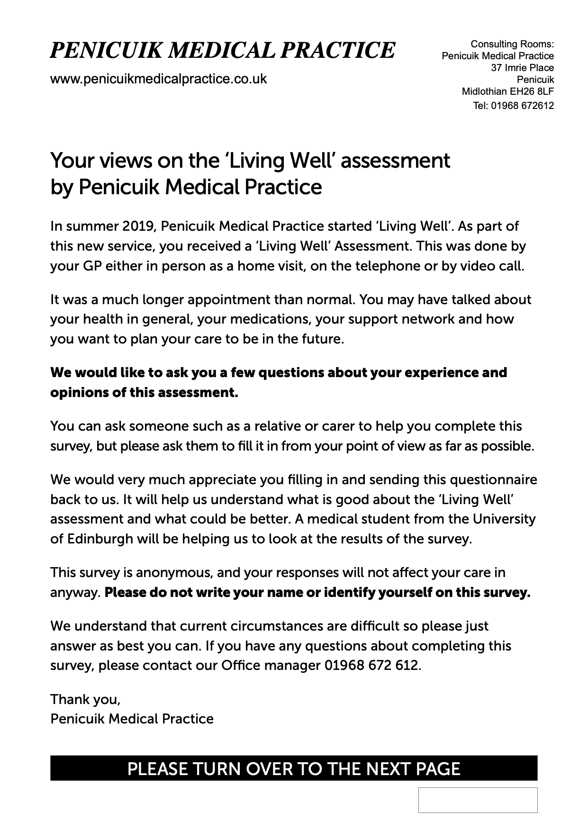
Living Well Patient Questionnaire
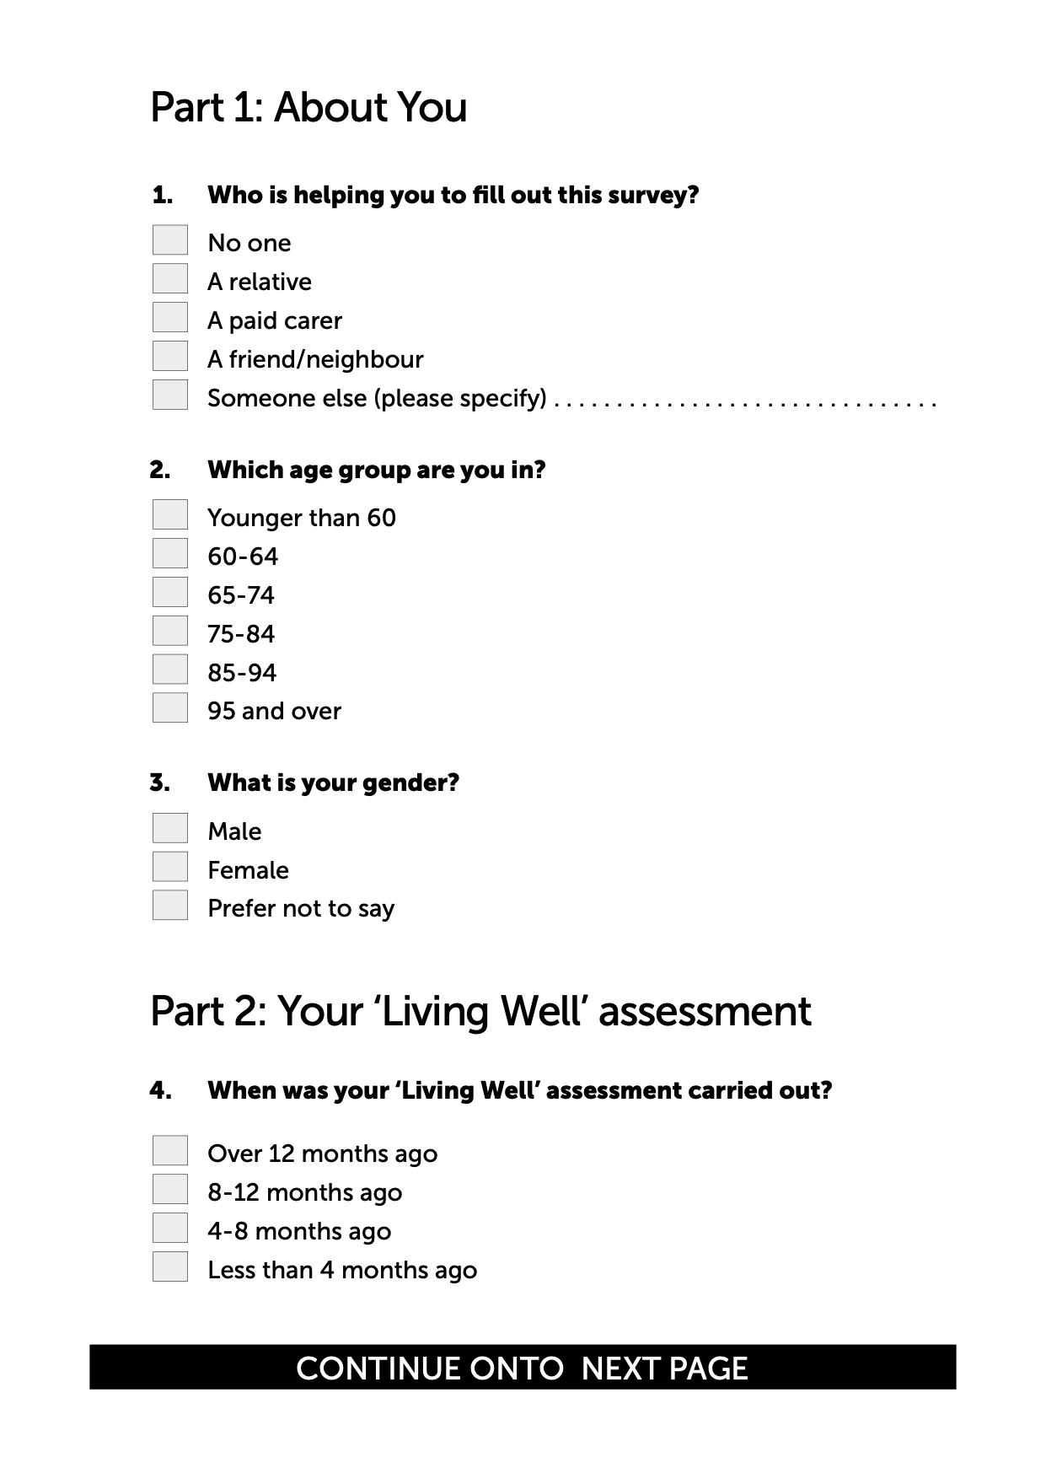
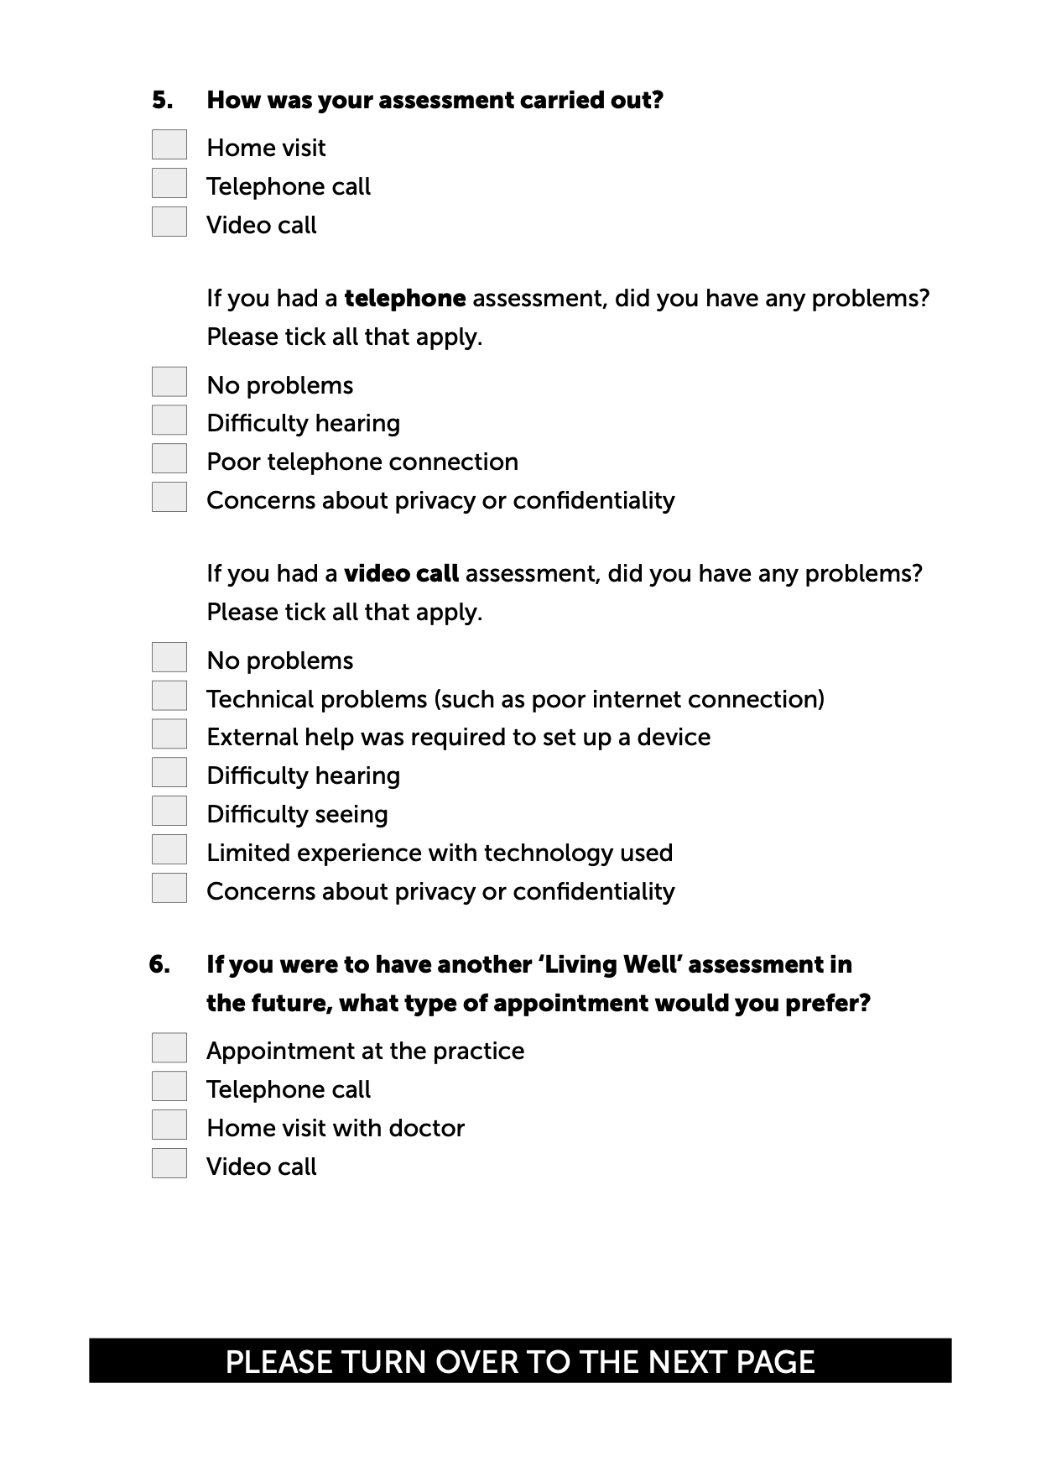
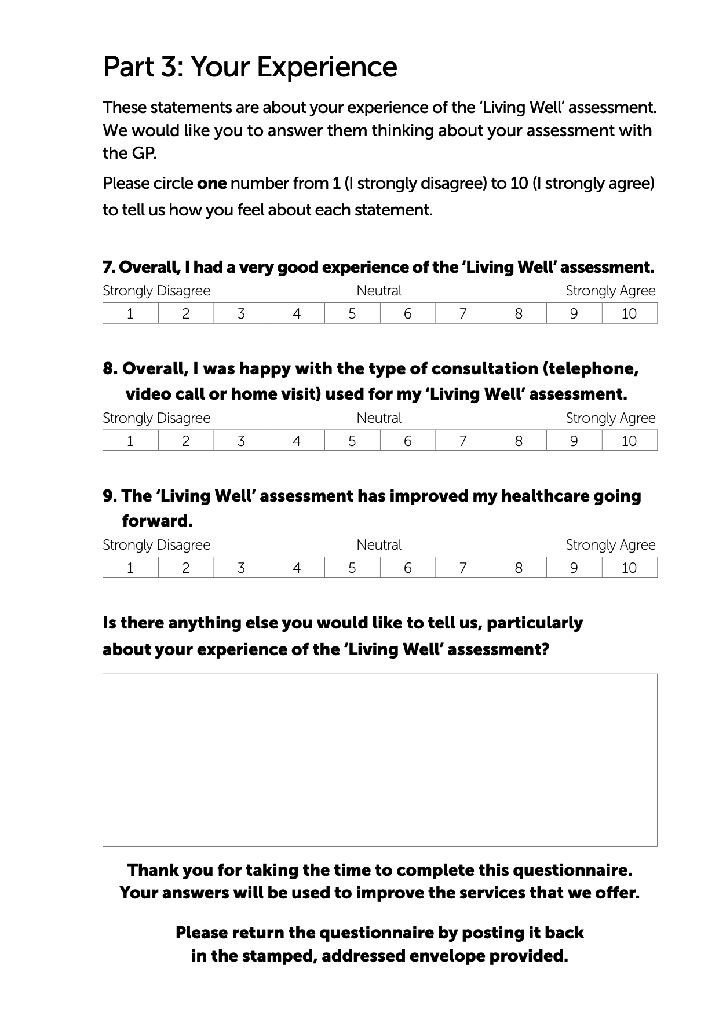
Qualitative Interview with GPs – Topic guide individual interviews

- What were your initial views on the new frailty project re assessing patient’s in their own home rather than in the practice?

Probe- What did you think would be the key advantages/disadvantages of the new approach to assessing patient frailty?
- Views on the assessment tool used

- What in your view would be the key outcomes of the frailty project?

Probe – what type of outcomes e.g., reduced hospital admissions/ A&E visits?
- How exactly would the intervention reduce hospital admissions?
- Is there evidence this type of frailty intervention works?

- Having done some frailty assessments in the patient’s home, generally speaking, how do you think the frailty project is going?

- What do you actually cover in the home visit when assessing patient frailty?

Probe- what are the benefits of doing the frailty assessment in the patient’s home?
Are there any drawbacks- if so what are they-and why?

- How does the frailty assessment in the patient’s home differ from what you were doing previously in the GP practice?

Probe- what do you think patients’ views were of the frailty assessment in their own home?

- From the patients you’ve assessed in the home, what impact do you think the new frailty assessment approach has had on patient care?

- Has the new approach resulted in any changes in practice when dealing with frail patients? If so what are they?

- Has there been any unintended consequences of the new approach to frailty assessment?

- Do you think assessing frailty in the patient’s home is sustainable? If yes, why? If no why not?

Probe- If yes is there anything that would need to change to make it sustainable? Could this new approach to frailty assessment be rolled out to other practices in the HSCP area?

- Looking to the future how do you see the assessment of frail elderly people evolving locally?

- What are the key learning points to take away from this frailty assessment project?

- Are there any last points you want to make about the frailty project and home assessments that we haven’t already covered or you want to expand on in more detail?

Qualitative Interview with GPs – Topic guide focus group interviews

- With COVID-19 and the lockdown, the frailty assessments were conducted by telephone or video. How did this compare with doing the frailty assessment face-to-face in the patient’s home or in the practice, as happened previously?

- What in your experience were the key differences between face to face and video/telephone frailty assessment consultations?

Probe- How long were remote consultations compared with face to face consultations?
- How do you think patients’ adapted to this new approach?

- How would you compare and contrast video consultations with telephone consultations?

Probe- were there any issues with video consultations? How were they organised? Did the technology work okay?

- Were there any advantages of video/telephone frailty assessment consultations compared with FTF consultations?

- Were there any disadvantages of video/telephone frailty assessment consultations compared with FTF consultations?

- Were there any unintended consequences of conducting the frailty assessment by video or telephone? If yes – please describe.

- Do you think conducting the frailty assessments by video or telephone will continue in the future even when lockdown is over?

Probe- how sustainable and practical is this remote approach to frailty assessment?

- What would you say is the key learning to take away from conducting the frailty assessments by video or telephone?

- Are there any last points you would like to make about conducting the frailty assessment by video or telephone that you feel haven’t been raised or fully discussed in this focus group?

Table S1: Themes and quotes from the open-end questionnaire data

Theme | Meaning | Quotation
1. Positive response to the assessment opportunity. | The provision of the assessment made participants feel that their overall wellbeing and general health was being prioritised by the practice. | Respondent 32. “This was good to know I am not just a number.” Female, 60-64.  Respondent 38. “I appreciated the call from my doctor, and it was good to know that they were checking up on me and asking me important questions about my health.” Female, 75-84.  Respondent 42. “It was good to know that the doctor is keeping track on my wellbeing.” Female, 84-95.  Respondent 41 “Very useful to have such a comprehensive interview with the GP who has primary responsibility for my care”.
2. More detailed and lengthier assessments welcomed. | The longer appointment time allowed for the discussion of multiple topics and improved the Respondent experience. The longer assessment also covered more topics, in detail, than a normal consultation in the GP surgery and provided an opportunity for the staff to thoroughly discuss and understand the needs of the patient | Respondent 37. “Would recommend this, a bonus with a longer appointment, more relaxed giving time to discuss different topics with the doctor.” Female, 60-64.  Respondent 2. “I found the house call I received from my GP to be very relaxing and helpful as there was a lot more time allowed to discuss any problems with her than there would have been during a normal surgery appointment.” Female, 75-84.  .  Respondent 28. “Staff know me and my needs more thoroughly following this assessment at home and in depth.” Male, 75-84.  Respondent 51 “The assessment was good, in enabling the beginning of a proactive relationship between patient and doctor, and resulting in the doctor actually having a personal knowledge - previously lacking.
3. Inadequate follow-up. | Some participants expressed disappointment over the absence of a follow-up with a doctor, to provide a conclusion to the assessment. | Respondent 6. “A note from the doctor as to some conclusions would have been useful.” Female, 85-94.  Respondent 8. “No follow up action. Think it would have been a good thing to be part of if it had worked how it should have.” Female, 85-94.  Respondent 51 “Unfortunately, the doctor then went on long term sick leave, and no other doctor has made contact since. We are now back to the scenario of being an anonymous number on a Respondent list, with no personal relationship with a healthcare professional”
4. Face-to-face consulting preferred. | Participants expressed the view that a face-to-face consultation is the preferred option. | Respondent 18 “For myself a face-to-face would be good. For someone on their own this would be beneficial.”  Respondent 34 “The scores for questions 6 and 8 reflect my view that at some point the assessment should be a face-to-face event”.  Respondent 26 “I would wish to have more person to person talk in the surgery.”  Respondent 30 “I know things are difficult just now but sometimes it would be really helpful to see a doctor.”  Respondent 45 “You can't beat a face to face examination with a doctor.”
5. Disability issues necessitated family involvement | For many respondents the presence of a family member improved their experience of the assessment, with many relying on their relative to hear the doctor or use the remote device over which the assessment was taking place. Trouble hearing due to the device used or personal difficulty with hearing was mentioned in multiple comments. | Respondent 6: Mum's hearing is not great so we are working to get that improved. She did not hear the doctor too well. The doctor was on speakerphone. The sound quality suffered so I had to relay a lot back to mum. Female, 85-94.  Respondent 27 “My father has dementia and cannot remember the assessment”.  Respondent 32. “This was good apart from my hearing difficulty.”

Table S2. Themes and quotes from interviews and focus groups with GPs
Table 3 – Themes and quotes from interviews and focus groups with GPs
Themes | GP quotes from interviews | Notes
Theme 1. Initial thoughts and key outcomes of the LWA
 | I initially thought this was a sensible idea because so much of good general practice is about being proactive rather than reactive. And this project was proactive. PGP8 | Whilst all GPs made reference to the daily time pressures they faced, the opportunity to evaluate a new approach was seen as relevant, particularly given the rising number of people living with frailty. The Penicuik GPs interviewed generally welcomed the project and thought it a positive initiative.
 | I thought it would be a lot of work. Initially I was sceptical. I did think, wow, that’s a lot of time with one patient, how cost effective is this? PGP7 | Some GPs had more qualified views. These GPs raised questions about whether spending 11/2–2 hours in a patient’s home (plus travel time) was an efficient use of GP time and financial resource.
 | When I initially reviewed the form used in the home I found it very long. There were a number of things around basic administration, and number gathering that could have been done by somebody else, not a GP so you as a GP could focus on the quality time you had to address the patient’s clinical issues and future plans. PGP5 | Additionally, several GPs, after initially reading the CGA (comprehensive geriatric assessment) thought it was very long, in the words of one ‘a bit clunky’. Several GPs believed many of the basic admin details of the form could have been completed by a non-GP.
 | I think the key thing was to identify these patients’ needs before they had a crisis so better ACPs. I’m also a great believer in the new KIS. Greater use of this is a key outcome. So for me the key outcome of the project was to reduce the risk of a crisis which in theory could reduce the risk of hospitalisation. PGP4 | Better KIS and ACPs completion rates
 | I was hoping we would have a better idea of how the person was functioning in their home circumstances, make our understanding of the patients’ we assess more holistic………….. I’m not sure I’d say it would reduce unplanned hospitalisations at this stage though. PGP5
 | More time with the patient meant I had a chance at thorough medicines review which could potentially reduce polypharmacy PGP3
 | Having done 7-8 of these, the biggest benefit was meeting the patients and getting more detailed knowledge about them both clinically and socially. The key outcome was making future plans, e.g., what will you do when your wife can’t look after you? When your lung condition gets worse and the hospital can no longer do anything more. What would you like us to do? PGP8
Theme 2: Assessment of project’s progress
 | Sometimes patients would be surprised about the content of some of the questions and the discussion. Maybe they wanted a more standard discussion about their medical issues. PGP9 | Patients unprepared for sensitive direct questions.
 | I didn’t think the modified CGA form flowed well. I actually preferred filling in the questionnaire back to front. So starting with the social, then the home setting and working back to the front. I think that made for a better consultation. PGP5
 | I think it’s going relatively well. I’ve seen a number of patients and benefited from spending longer time with them - gaining better knowledge. A bit in the dark on measuring differences made, what’s the impact been? Maybe that’s what you are doing this for. PGP8 | One GP believed the project was going relatively well but was unclear on what happened to patients following the assessments.
 | I think it’s a project in evolution. The project lead has put in a huge amount of work and really developed the project. There have been challenges with the project around time allocated and the winter pressures and the senior partner being off. And then of course Covid-19 hit us. We’ve had our challenges with it. PGP4 | GPs reflected on the external challenges the project has faced on a variety of fronts.
 | I think the project has surpassed my expectations. I thought the time allocated to each assessment was appropriate and time well spent given all the key information you are gathering from the patient. PGP7 | One GP believed the project had surpassed expectations:
Theme 3: Benefits of a longer assessment in the patient’s home
 | In strictly human terms, I assessed one patient who had been discharged from hospital 6 weeks previously and was basically living in the kitchen dining room area. In the assessment, we discussed how to get her confidence and mobility improved. The lengthier time let us discuss more sensitive issues which fast-tracked relationship building with that patient. That’s priceless. PGP6 | The opportunity to conduct a more holistic assessment was frequently mentioned by GPs as a major positive of the project.
Key Theme 4: Unintended consequences (Negative )
 | You’ve gone out there to prevent them being severely frail and you’ve instead identified them as severely frail. You uncover new things because you have more time. I think we are not coding people as well as we could be. All the people I’ve seen have been coded up and now are severely frail. I think in turn that that has created more demand.  PGP2  I think all the patients changed on the severity level to severe. But I think that was down to the EFI coding because we code on the diagnosis and we don’t code for any symptoms and significantly a large chunk of EFI coding is symptoms, like dizziness for example. That’s not a medical diagnosis as such. That’s why I’d say that most of our EFI coding, are artificially lower in severity. PGP4 | The GPs identified three main unintended consequences:  (i)In most cases patient frailty was adjusted from moderate to severe  (ii)Increase patient expectation – home visits and extended time with a GP would become routine  (iii)Longer assessments increased GP workload – e.g., additional referrals to primary care teams.
Key Theme 4: Unintended consequences (positive)
 | I think another unintended consequence might be more patient contacts in primary care, more requests for home visits but I don’t think that’s necessarily a bad thing. There is a culture in that elderly age group of not wanting to bother the doctor so maybe building that relationship does encourage them to be a bit more proactive in asking to see us. PGP7  I also think there’s a far more informal cultural change at the doctors’ end from doing this project. I’m now doing more about frail patients’ future intentions, e.g., what do you want to do if something’s happened to you? PGP5 | From a patient perspective relationship building could encourage patients to come forward more readily with health concerns. From a GP perspective, GPs were more aware of addressing patients’ future end of life care issues.
Key Theme 5: Key learning, sustainability and roll out
Key learning
 | If you look at the EFI coding in people who haven’t had the lengthy home assessment I think it is incorrect data because it’s not complete. You have to have consistency of GPs doing it the same way. The EFI coding isn’t as accurate as the CGA coding. PGP4  I think from this project I’ve learned I’m not coding people properly and not identifying people that are in fact severely frail. PGP1 | The need for more accurate frailty coding to recognise patients with severe frailty
 | From a personal point of view it’s meant re-visiting care of the elderly and revisiting things like continence and confidence that can prevent people going out. Basically, I’ve learned the importance of better holistic care. PGP6  As I said earlier I was a bit sceptical when it started. But I learned more about frailty and how measures to address frailty are better understood when assessed in that person’s social circumstances, in their own home. Also learning that poor mental health can impact on frailty. PGP7 | Greater appreciation and awareness of frailty, anticipatory care planning and holistic care
 | It doesn’t have to be a GP that takes down all the background information, getting permission for a KIS etc. That could be done by an HCA. If other people are taking down basic admin. It won’t take up as much of our time. I also think that a nurse could do most of the assessment. We GPs could deal with the more significant clinical issues like medicines. Let us as doctors do the doctoring. PGP3  I think whilst there are huge advantages of the GP doing the assessment in the home, lots of it could be done by someone else. It is very time consuming and therefore costly if it’s a GP. I honestly think it doesn’t have to be a GP. Other health care professionals in the practice could do it. PGP7 | Some of the lengthier CGA form could be completed by non-GP practice staff and/or other HCPs could cover the main assessment areas
Sustainability
 | I’m not sure about sustainability, resource wise. The time spent on one home visit means I’m not seeing other patients in the surgery. So in 2 hours in that half day I’ll see 12-13 patients in surgery. Plus speak to some on the phone and maybe a house call too. So you do the maths. PGP3
Roll out
 | Yes, I think it could be rolled out to other practices in Midlothian. We are larger than most towns in the area but we are not too dissimilar in terms of socio-demographics. I think a lot depends on the evidence of the intervention in terms of what changed, what made a difference. PGP2  I think an initiative like this is easier to do in a large practice like ours with 12 GPs and wider support staff. It might be more difficult in smaller sized practices with only four GPs. I think the project’s shown potential to make a difference and to be considered elsewhere. PG4D | GPs were asked to consider whether they felt the Penicuik Living Well home assessment frailty initiative could be rolled out across Midlothian
 | GP quotes from focus groups | Notes
1) Importance of admin staff setting up video calls to save GP time | When it’s just me and the patient trying to sort the video consultation ourselves, that is much more frustrating, time-consuming and sometimes doesn’t work. My take-home message is- if doctors are going to use this technology they need to be assisted by admin staff to make it run more seamlessly. That’s a more efficient way to work. PGP10 | GPs believed that having the video calls with the patient (and/or their family member) pre-arranged by practice admin staff was crucial.
2) Importance of family member being present for video consultations | It’s very useful to have a member of the family there. I think the majority of mine would have struggled without a family member to set it up PGP12  I've had patients where they haven’t been able to work the tech, and it's ended up being a phone call. Those assessments haven’t worked so well. PGP19
3) Technical problems and patient issues could undermine video consultations | I will say that the IT still is not 100 per cent, it does need some tweaking.  PGP14  So disadvantages with video, just technical issues – not being able to connect - and for some reason audio stopping, or video stopping, and you don't really know why –that’s not good. PGP18  Some very frail older people physically struggle to work the technology - arthritis for example. PGP16  There's no doubt that there are some barriers to frail people using video. Physical reasons, hearing difficulties, cataracts. But with the help of relatives, I think people are more, gung-ho, and quite happy to crack on with it. We've been pleasantly surprised that it's not so much of a barrier. PGP18 | GPs reported having technical problems with some of their video consultations which was unsatisfactory for both the patient and the GP.  Hearing problems were another issue
4) Face to face assessments are the gold standard but the Living Well frailty assessment was viable in a 30 minute video consultation | Face to face, it’s the gold standard but I don’t know if I would consider it safe in the current situation. Also, I don’t know if a gold standard is needed all the time by a doctor. With video I can get lots of what I need in exactly the same way, minus some of the very top tier gold standard elements and that’s good enough for me. And it’s more efficient and it uses resources better than lengthy home visits. PGP13  I’ve tried both methods. With home visits you get more of a feel. But the ones we’ve been doing on video, you can do three or four for the price of one home visit, and the ones I’ve done by video have invariably seemed to be well-appreciated. The family mostly manages to be there as well. If I had to choose, I would go with the video method as the future. PGP15 | Some GPs reported that when they didn’t know the patient the video consultations took longer than the usual average 30 minutes (up to 45 minutes in some cases), leaving less time to type up the patient’s notes and left GPs feeling rushed to prepare for the next video consultation.
5) Assessment by video (without technical problems) were better than telephone | Compared to telephone, video adds another layer – visual cues-and is a midpoint between face to face, and a telephone consultation. There’s definitely positives about it. PGP17  With video, compared with telephone, it’s the quality of the non-verbal communication. General practice is an awful lot about continuity and relational continuity. Being able to see someone that I hadn’t seen for at least six months was a richer engagement. On the telephone, it’s a transactional arrangement. I’m almost ticking boxes as I go along. PGP10  I've got to admit, it is seriously uncomfortable talking about DNAR on a phone. PGP18 | GPs believed video consultations (when there were no technical problems) were better than telephone consultations  This GP highlighted the non-personalisation of conducting the EFI assessment by telephone, especially when discussing DNARs.
6) With COVID-19, video consultation has benefits over home and/or practice visits | Something as simple as just smiling, you can see them smiling, they can see you smiling. And there's just a bit more of a shot at bedside manner. It's very difficult to have bedside manner on a telephone consultation. And it's even difficult to have bedside manner on a face to face consultation with full PPE. PGP17  With COVID, actually reducing footfall into practice is safer. And the other thing in COVID times, video consultations reduced the need for unnecessary PPE just to have a conversation. So again, environmentally, right the way through to time and cost and safety, remote is just better from that regard. PGP10  I think you get more value out of doing video surgeries, you get to access the notes. PGP14  It’s really much more straightforward when you can see them and have their collateral history and you also have your own computer so you can dig up in the notes what they said two years ago. PGP12 | Some GPs said with video consultations (where they worked well) you could actually see the patient more clearly than with a face to face with the GP wearing PPE and the GP wearing a mask. It was therefore possible to pick up on visual cues better  Inlike a home visit assessment, GPs were able to access the patient’s notes during the consultation which they believed was beneficial to the EFI assessment.  Patients and their family member didn’t have to visit the practice for the assessment or the GP visit the patient’s home. GPs believed that this “reduced footfall” was safer for all concerned.
Disadvantages of video consultation | It’s just better being able to speak to a patient face to face. It just feels better for patients I think and obviously from a GP viewpoint, it’s clinically better to have the patient in front of you”. PGP10 | There were disadvantages with video consultations when compared with face-to-face consultations as they weren’t what both participants were used to -“the norm”- and there wasn’t the opportunity for a physical examination

